Research Topics:

Brain Tumor Detection and prediction using CNN model

Normal Cell labels count: 32

Tumor Cell labels count: 201

Training data shape for CNN (70-30): (163, 128, 128, 3) (163,)

Testing data shape for CNN (70-30): (70, 128, 128, 3) (70,)

Test Accuracy for CNN (70-30): 95.71%

Training data shape for CNN (80-20): (186, 128, 128, 3) (186,)

Testing data shape for CNN (80-20): (47, 128, 128, 3) (47,)

Test Accuracy for CNN (80-20): 97.87%

Normal Cell labels count: 30

Tumor Cell labels count: 187

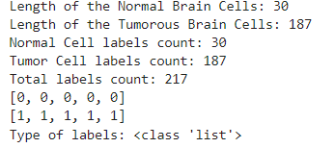



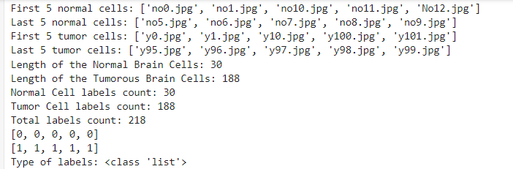

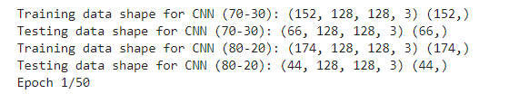

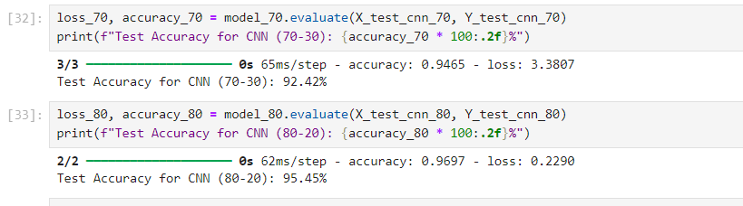

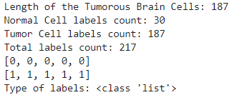

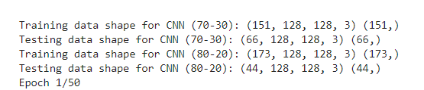

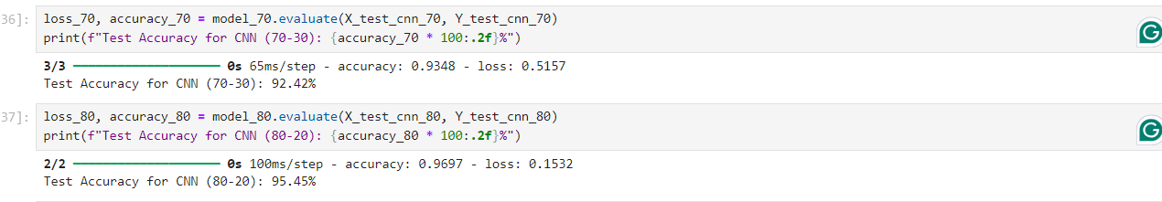

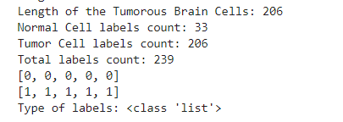

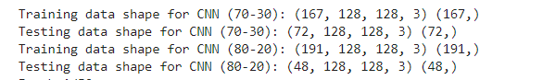

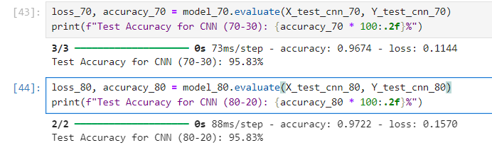

7000+ datasets

Accuracy find out using CNN model

